**LEBANESE AMERICAN UNIVERSITY**

**USAID – HIGHER EDUCATION SCHOLARSHIP PROGRAM**

**HES - Volunteering Program Verification Form**

This form is to be used to document volunteering hours. If a student volunteers for multiple organizations, a separate form must be used for each organization. **This form must be turned in by the 28th of each month, the latest.**

I certify that the scholar Makram kordab completed a total of 22 hours of service at InnovaThrive.

The hours were completed hours as per the below:

Hours # 5 (date) _2/12 – 6/12_ (initials of supervisor) __A.K.___

Hours # 7 (date) _9/12 – 13/12_ (initials of supervisor) __A.K.___

Hours # 5 date) _16/12 – 20/12 (initials of supervisor) __A.K.___

Hours # 5 date) _23/12 - 27/12 (initials of supervisor) __A.K.___

Brief description of the activities the scholar performed or participated in:

Corrected Researches to meet InnovaThrive Standards   
Organometallic Chemistry: Reactivity and Applications in Synthesis  
This research focuses on the reactivity of organometallic compounds and their applications in chemical synthesis. It explores the mechanisms of organometallic reactions, their role in catalysis, and their utility in forming complex molecules for pharmaceuticals, polymers, and materials science.  
  
Surface Chemistry and Nanostructures: Synthesis, Characterization, and Applications  
This research examines the principles of surface chemistry in the context of nanostructures. It covers methods for synthesizing nanomaterials, techniques for characterizing their properties, and their applications in fields such as electronics, energy storage, and biomedical technologies.

Written feedback about the scholar’s performance:

Makram Kordab’s contributions in reviewing and correcting the research were highly valuable. His insights and attention to detail ensured the work met high standards of clarity, accuracy, and relevance. His corrections enhanced the overall quality and coherence of the research, making it more impactful and aligned with academic excellence

Please rate the overall performance of the scholar at your organization:

|  |  |  |  |
| --- | --- | --- | --- |
|  | Mastery (5) | Proficient (3) | Emerging (1) |
| **Problem solver** | X |  |  |
| **Engaged & Committed** | X |  |  |
| **Open-minded & multicultural** | X |  |  |

Signature

& stamp

__________________________

_

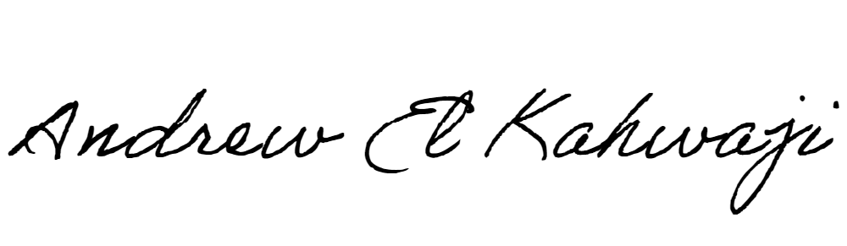

Printed Name _Andrew El Kahwaji_

Date __26/12/2024___

Email __andrew.lifesculptor.coo@gmail.com __

Phone __+961 71 914 378__